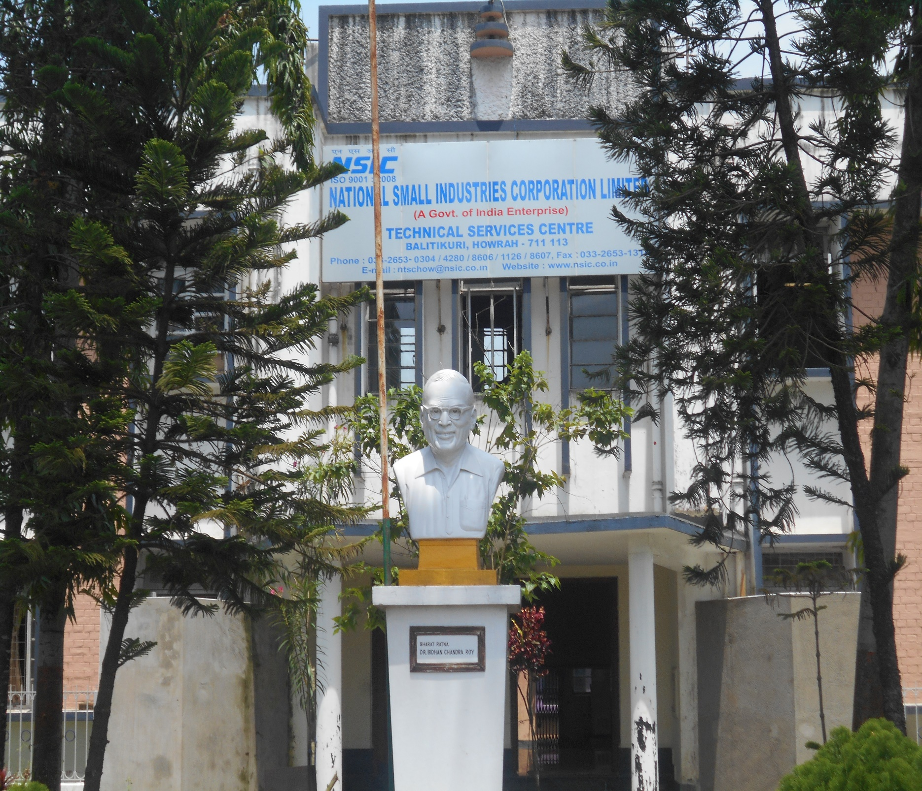

|  |
| --- |
|  |
|  |
| Installation of Solar Panel  August 9, 2023  NSIC |



MODULE ?

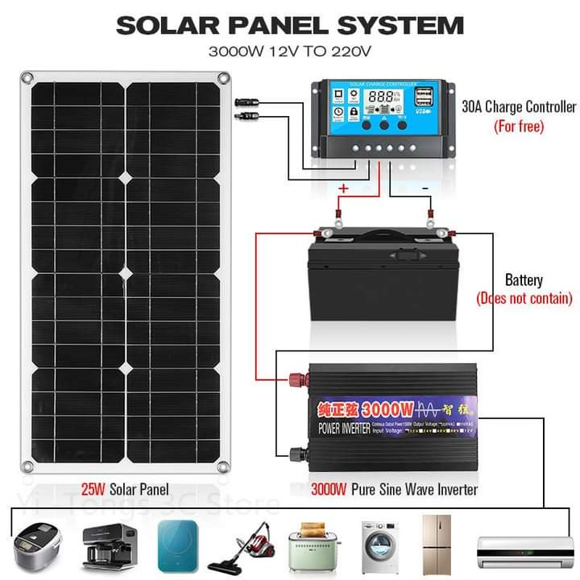INTRODUCTION:

When we want to put solar panels in place, we need to make sure they're securely and permanently attached to sturdy metal structures. The kind of structures we use depends on where we're putting the solar panels and how big the whole setup is. For smaller setups like solar panels on houses, we use simple structures to hold the panels. Think of it like putting up shelves for the solar panels. For things like solar-powered streetlights, traffic signal lights, or solar-powered pumps, we use structures that are like poles. These poles hold the panels up high.But when we're dealing with bigger setups like solar power plants or solar panels for things like railway signals, we need even bigger structures. These structures are like frames that hold a whole bunch of solar panels together.So, the size of the solar panels and where we're putting them determines the kind of structures we use to keep them in place.

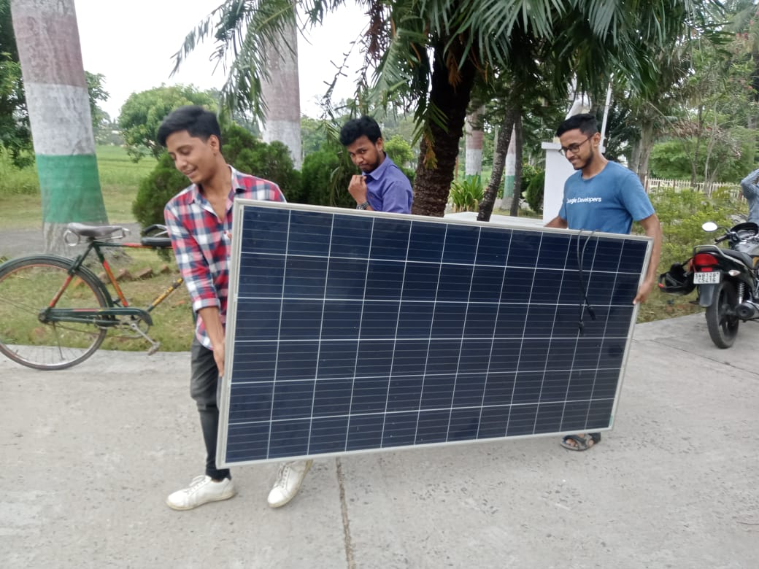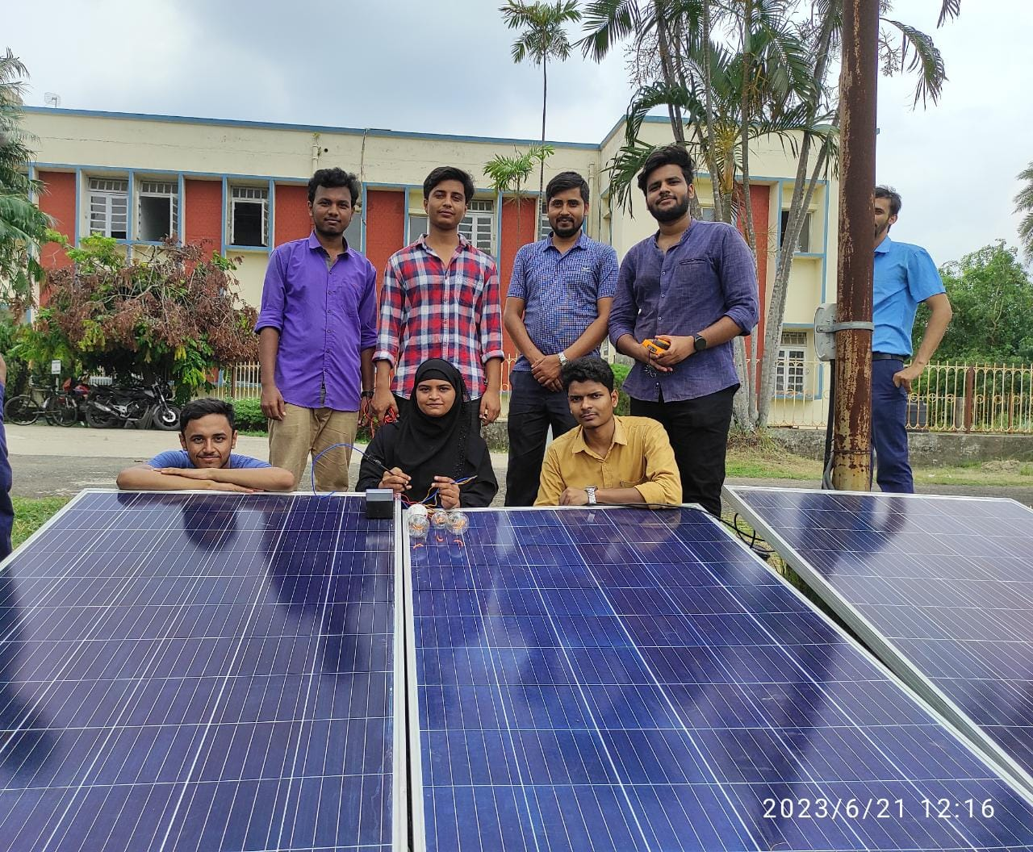

Intro 2:

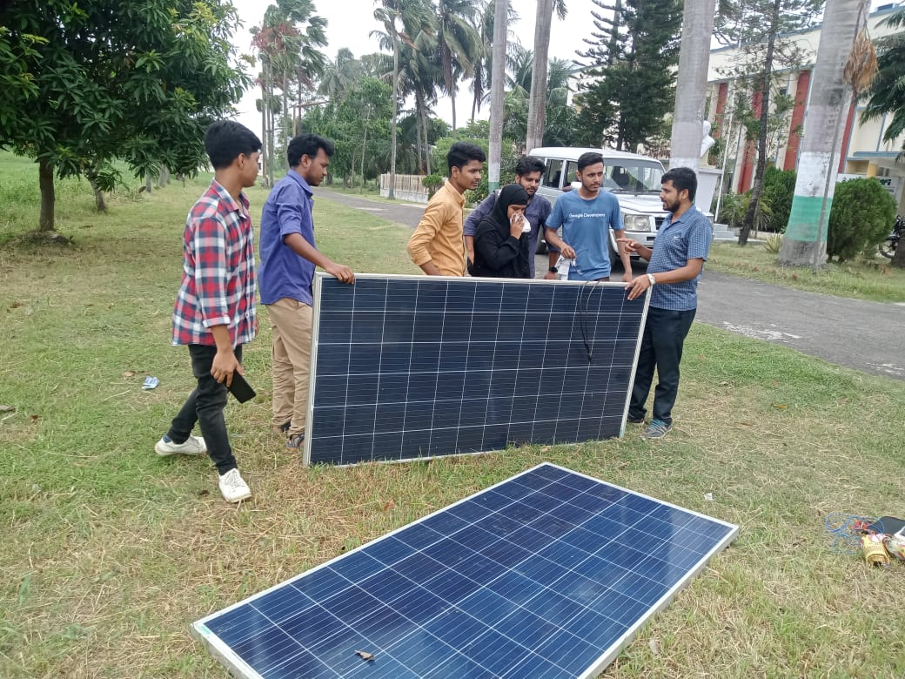Solar panels are securely placed on metal structures depending on their use and size. Small systems, like home setups, use basic mounts. Solar streetlights

and pumps use pole-mounted frames. Larger systems, such as power plants, use bigger arrays. These structures ensure the panels stay in place and work well.

Testing before installation:

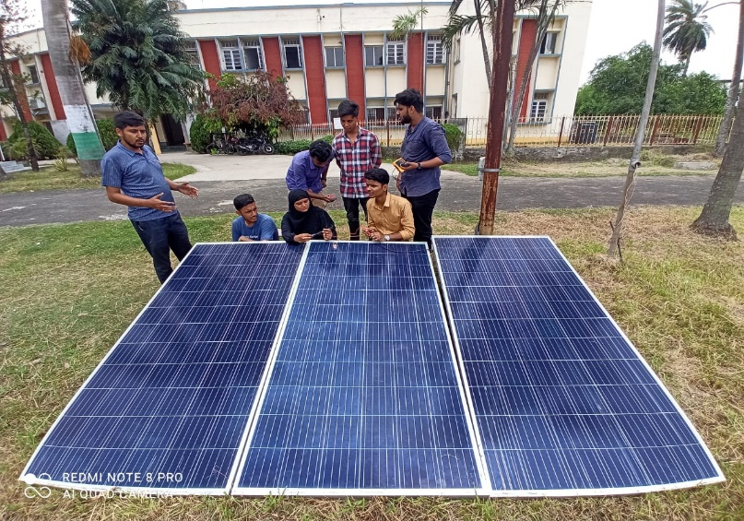Solar panel testing is done before installation to ensure they work properly. This involves checking for any defects, making sure they produce the expected amount of electricity, and confirming they meet safety standards. Testing helps identify issues early, so panels can be fixed or replaced before installation.

Voc-Open circuit voltage Isc-Short circuit current Vmax- Maximum Voltage Imax- Maximum Current Pmax- Maximum power at Standard Test Conditions or Peak Power Output .

INSTALLATION GUIDELINES:

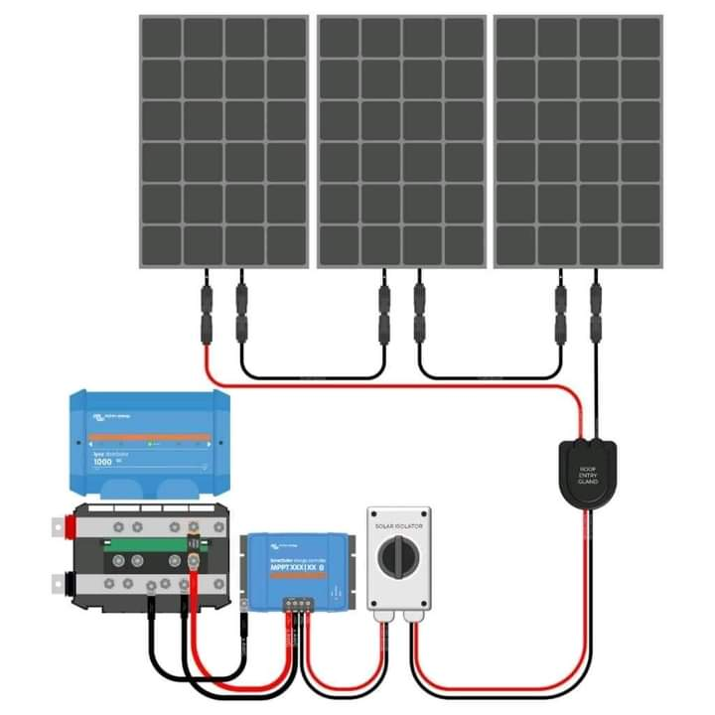

1. Location and Site Preparation:

~ Choose a location with maximum sunlight exposure.

~ Ensure the area is free from shading, trees, and obstructions.

~ Clean the installation site and remove any debris.

2. Mounting Structures:

~ Select appropriate mounting structures based on system size (roof, ground, pole).

~ Ensure structures are strong and secure to withstand weather conditions.

3. Electrical Wiring:

~ Use proper wiring and connectors suitable for outdoor use.

~ Minimize wire length to reduce energy loss.

~ Connect panels in series or parallel as required by the system design.

4. Panel Installation:

~ Wear appropriate safety gear during installation.

~ Place panels on the mounting structures and secure them firmly.

~ Follow the correct orientation (angle and direction) for optimal sunlight exposure.

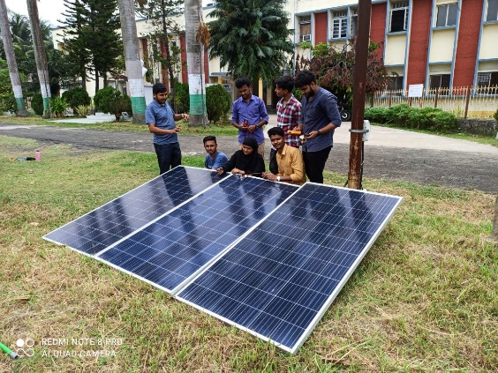5. Inverter and Components:

~ Install the inverter and other components in a clean, dry, and well-ventilated area.

~ Ensure proper grounding to prevent electrical hazards.

~ Connect panels to the inverter according to the manufacturer's instructions.

6. Electrical Safety:

~ Turn off all electrical sources before working on the system.

~ Avoid working during wet or rainy conditions.

~ Test for voltage and ensure circuits are not live before handling.

7. System Testing and Commissioning:

~ Check all connections and wiring for correctness.

~ Perform a comprehensive system test to verify panel output and inverter functionality.

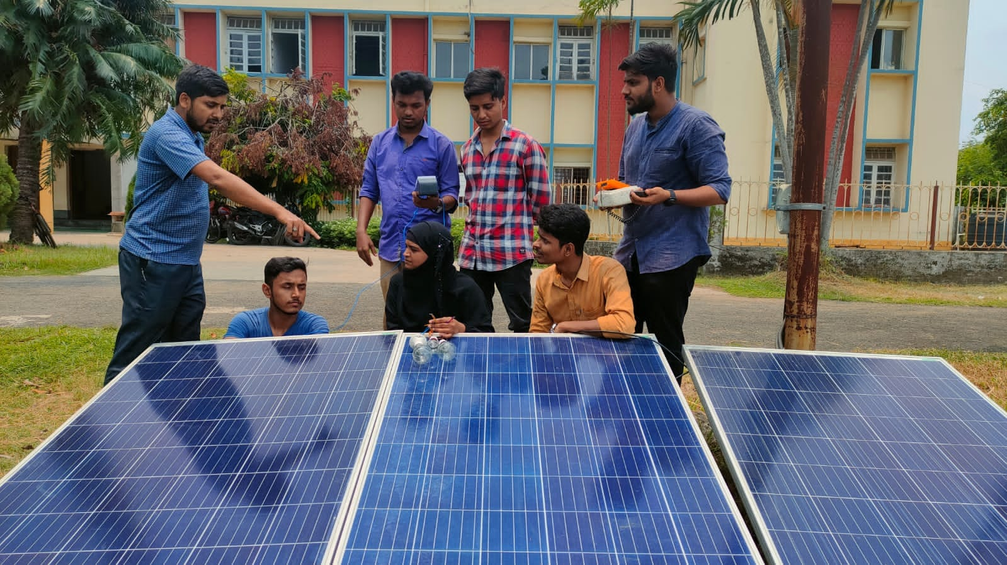~ Ensure the system meets safety standards and local regulations.

8. Documentation and Maintenance:

~ Keep records of system specifications, warranties, and installation details.

~ Provide user manuals and documentation to the owner.

~ Regularly inspect and clean panels to maintain optimal performance.